The Ragged Hole Challenge #1 (Pistol):
Target: 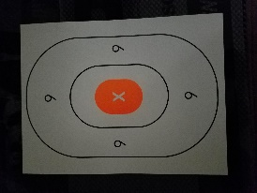
Distance:
- Stage 1: Pistol 3.5 yards
Ammunition: 10 rounds
Position: Standing (low-ready)
Time: Unlimited
Score: Accuracy
The Ragged Hole drill has been around for a long time. You will slow fire three rounds into a single, small point on your target for each stage.
Take your time and use the exact same point of aim each time. Do not chase your shots or try to make corrections.
Attach this to the target.
Full Name: ___________________________________
Today’s Date: ______________
Score:

