CMP Local Chapter #24952

Based on USPS

Hit Factor Scoring Points and Penalties

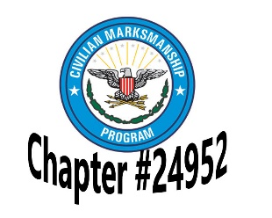
Targets:
The target used for our CMP Challenge is the Metric that is popular in the United States. It is scored with the target having specific scoring zones, labeled A, B, C, and D. Each is worth a decreasing point value respectively.
Scoring is based on the hole in the target caused by the bullet and scoring is in the favor of the shooter. By that I mean all you have to do is touch the line of a scoring zone to be awarded that point value. There is also a scoring line surrounding the entire target edge
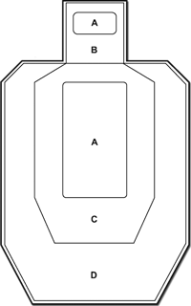

Major | Zone | Minor
5 | A | 5
4 | B | 3
4 | C | 3
2 | D | 1

Power Factor:
Speed, Accuracy and Power are the three legs of the motto of IPSC and USPSA. This is where the Power leg comes into play. Heavier recoiling ammunition is harder to shoot quickly and accurately. The idea is that this heavier recoiling ammunition should have a leveling factor applied to it so that those shooting .45ACP aren't at a disadvantage to those shooting light recoiling 9mm rounds. The idea of a power factor uses a simple formula relating the weight of the bullet and the muzzle velocity to determine an energy rating for that particular round out of that particular handgun.
You can see in the table above how "making Major" adds a full point difference on each shot that isn't an A zone hit. But also notice that Accuracy trumps them all in the end. If you can shoot A zone hits, it doesn't matter what power factor you score as you will always make 5 points for every hit.
Mikes and No-Shoots:
Missing a target is referred to as a Mike (miss) and is a penalty of -10 points. Hitting a white "No-Shoot" target is worth the same -10 penalty. Mikes and No-Shoots are the most common scoring penalties and some of the easiest to avoid. Shoot as fast as your sights allow you to shoot and be sure of every shot you break. Being a little slower with good hits and no Mike or No-Shoot penalties is a great way to do very well at a match.

