Slow Fire Drill (Gandalfrso)
Firearm: Pistol
Rounds: 20
All shots must be on target.
Target: 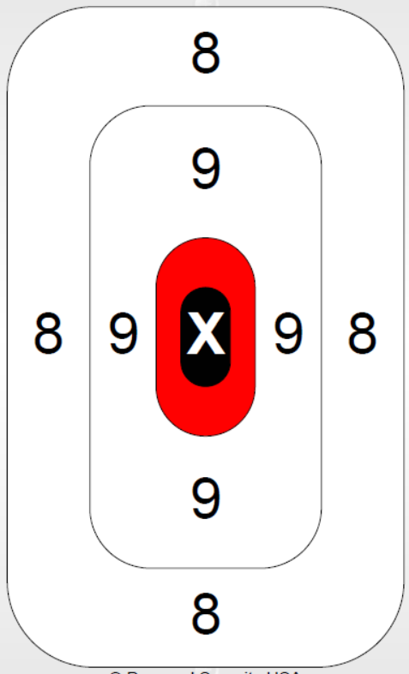 Available to print online @ LINK *
Time: unlimited
Two handed standing position at the high ready.
Five shots on target at distances listed below:
- 3.5 yards in red X circle only
- 7 yards not more than 2 in 9 area/zero in 8 area
- 10 yards not more than 3 in 9 area/zero in 8 area
- 15 yards not more than 2 in 8 area
Each shot reinforces the basics and the shooter also verifies sight zero.

* https://bit.ly/3EnNiCo

