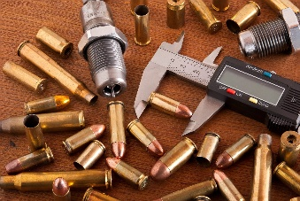
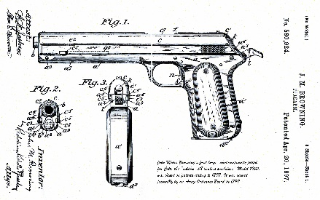
GANDALFRSO
.COM

Definition of “Engaged in the Business” as a Dealer in Firearms
What Do You Need to Know?
- The NPRM will be open for a 90-day comment period once it is published in the Federal Register. ATF will provide a link when available.
  - Note that comments will be posted within a few days of being submitted. However, if large volumes of comments are being processed simultaneously, your comment may not be viewable for up to several weeks. Please keep the comment tracking number that is provided after you have successfully uploaded your comment.
The NPRM proposes to incorporate the BSCA’s definition “predominantly earn a profit,” creating a stand-alone definition of “terrorism,” and amending the definitions of “principal objective of livelihood and profit” and “engaged in the business” to ensure each conforms with the BSCA’s statutory changes and can be relied upon by the public.
Furthermore, the NPRM specifically proposes to clarify when a person is “engaged in the business” as a dealer in firearms at wholesale or retail by:
- Clarifying the definition of “dealer” and defining the terms “purchase” and “sale” as they apply to dealers;
- Clarifying when a person would not be engaged in the business of dealing in firearms as an auctioneer, or when purchasing firearms for, and selling firearms from, a personal collection;
- Setting forth conduct that is presumed to constitute “engaging in the business” of dealing in firearms, and presumed to demonstrate the intent to “predominantly earn a profit” from the sale or disposition of firearms, absent reliable evidence to the contrary;
- Clarifying that the intent to “predominantly earn a profit” does not require the person to have received pecuniary gain and that intent does not have to be shown when a person purchases or sells a firearm for criminal or terrorism purposes;
- Adding a single definition for the term “personal collection, personal collection of firearms, or personal firearms collection” and adding a definition for the term “responsible person”;
- Addressing how former licensees, and responsible persons acting on behalf of former licensees, may lawfully liquidate business inventory upon revocation or other termination of their license; and
- Clarifying that licensees must follow the verification and recordkeeping procedures in 27 CFR 478.94 and Subpart H, rather than using an ATF Form 4473 when firearms are transferred to other licensees, including transfers by a licensed sole proprietor to that person’s personal collection.
The NPRM will be published in the Federal Register, and open for a 90-day comment period from the time it is published.
The exact rule LINK
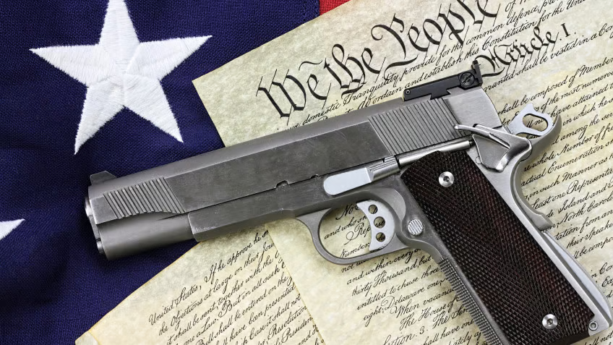

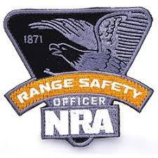
4710 Fishcreek Road, Stow, Ohio 44224
(330) 606-4583 mailto:dale@gandalfrso.com

