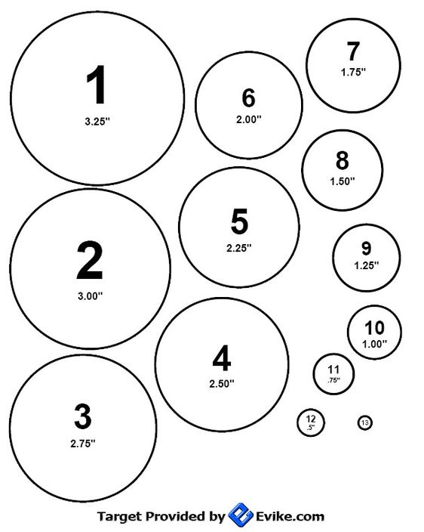

You have 10 shots to show how small you can shoot. Shot has to be inside the circle. Start big and move to small. Smallest circle wins.

***22 Ladder Target #2*** *Date of Challenge: ___________ Location: ________________*

*Shooter #1 Full Name: ________________________ Signature: ____________________________*

*Shooter #2 Full Neme: ________________________ Signature: ____________________________*

*Score: __________________ Distance: 5 yards iron / 7 yards optic Rounds: 10*