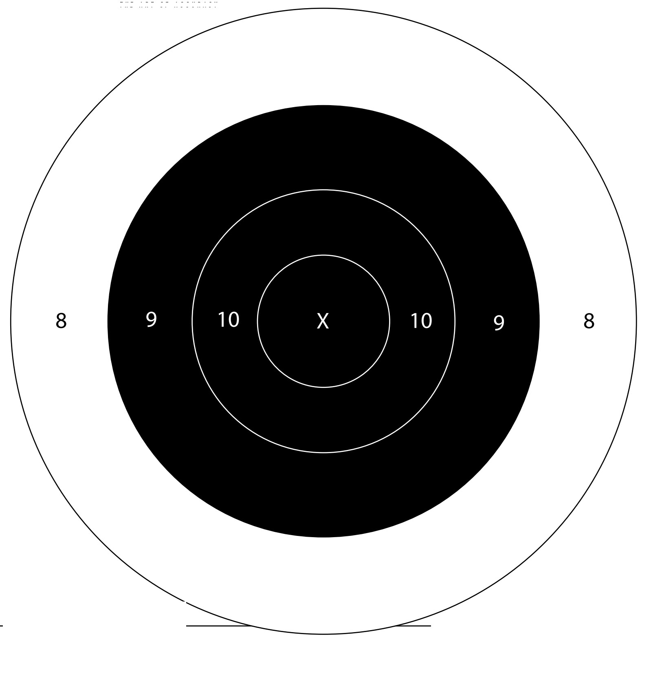

***45 Ladder Target #5*** *Date of Challenge: _________________________ Location: _______________________*

*Shooter #1 Full Name: ____________________________________ Signature: ________________________________*

*Shooter #2 Full Neme: _____________________________________ Signature: ____________________________________*

*Score: ___________ Distance: 12 Yards (iron) Rounds: 8*