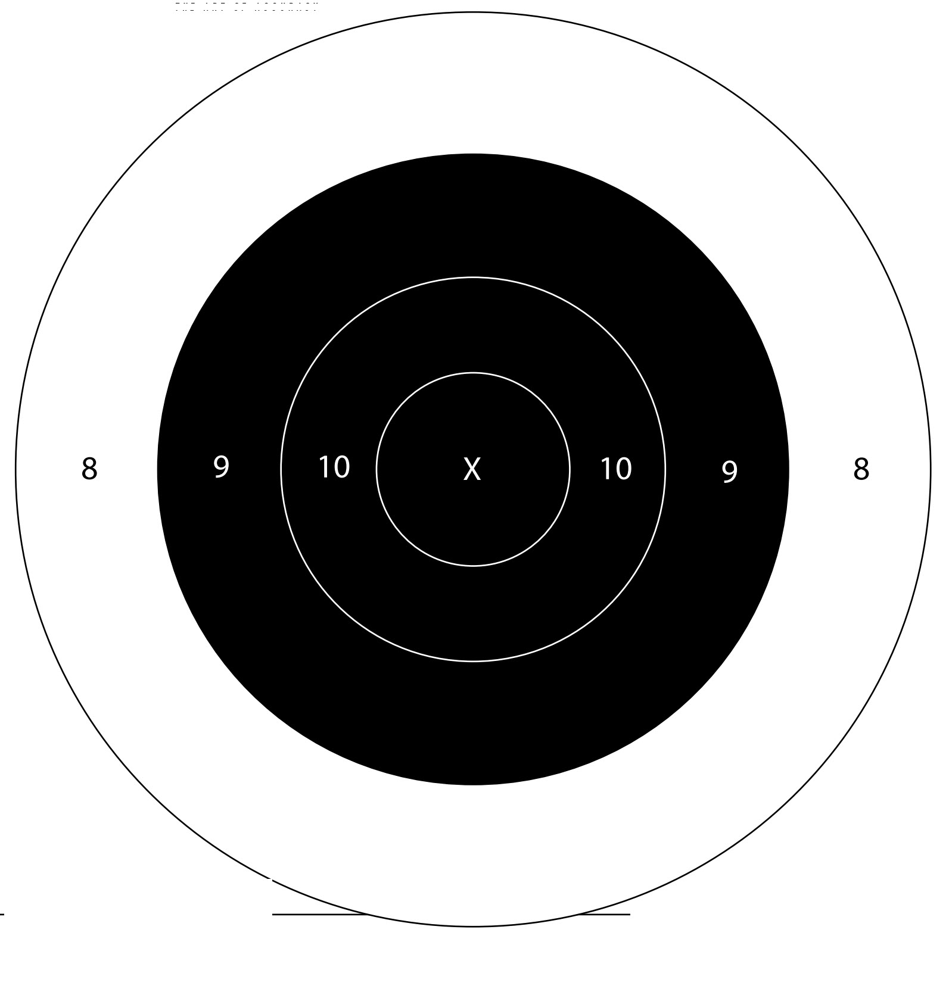

***9mm Ladder Target #2*** *Date of Challenge: _________________________ Location: _______________________*

*Shooter #1 Full Name: ____________________________________ Signature: ________________________________*

*Shooter #2 Full Neme: _____________________________________ Signature: ____________________________________*

*Score: ___________ Distance: 10 Yards (iron) – 15 Yards (optic) Rounds: 10*