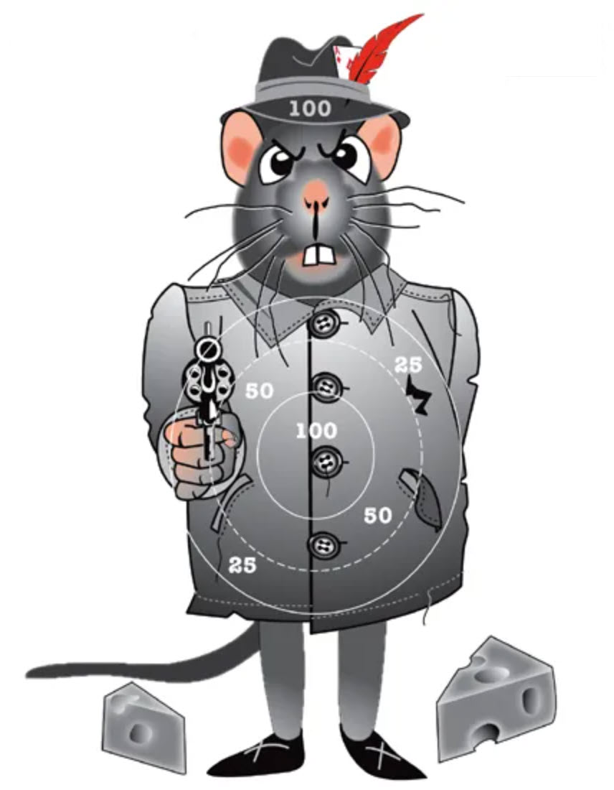

***9mm Ladder Target #4*** *Date of Challenge: __________________ Location: ________________*

*Shooter #1 Full Name: ________________________ Signature: ____________________________*

*Shooter #2 Full Neme: ________________________ Signature: ____________________________*

*Score: ___________ Distance: Yards: 7 iron/10 optic Rounds: 8 (Score the most points)*