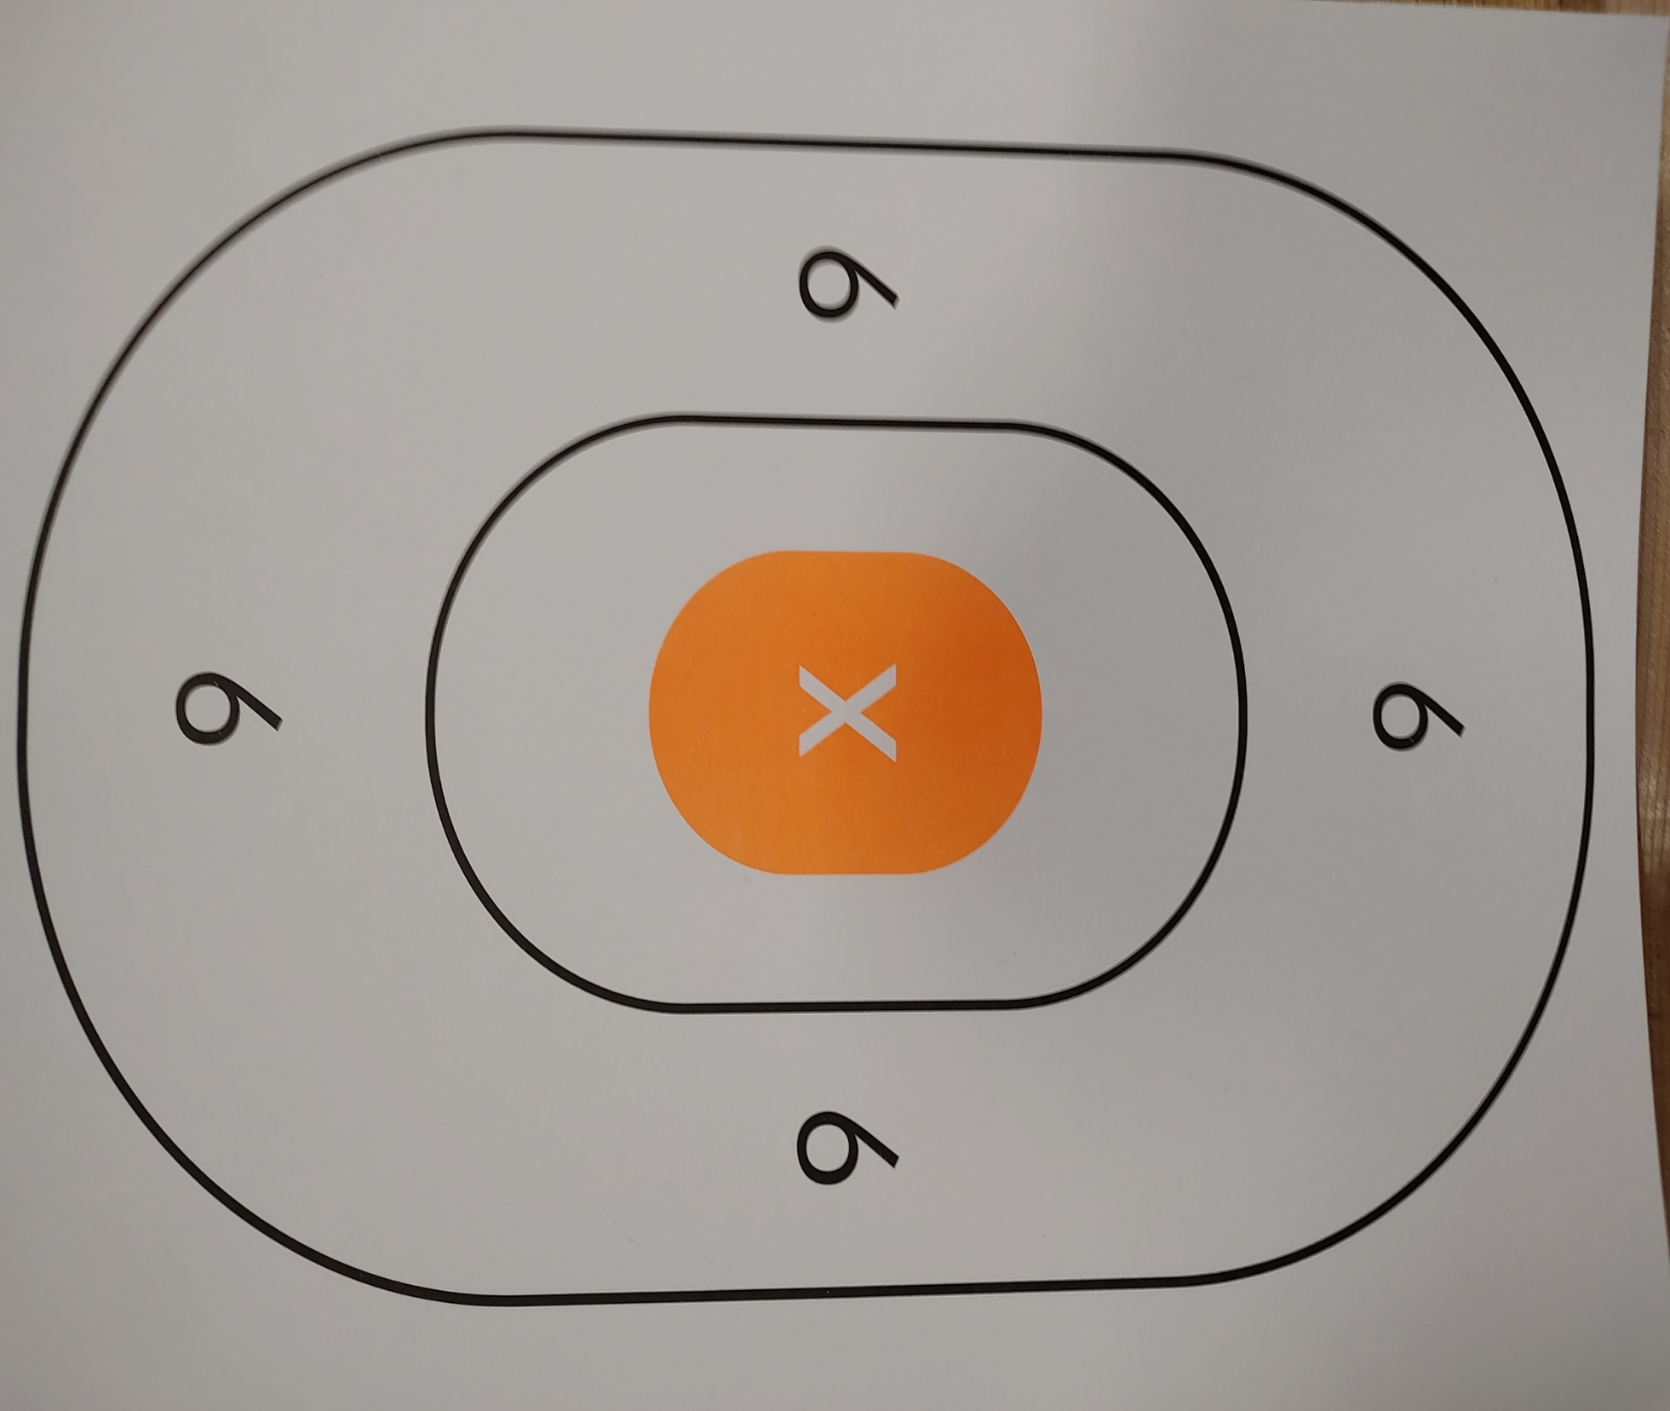

Double Action Revolver Placement Target Date:_____ ____________ Location:______________

Distance: 7 yards Rounds: One Cylinder (1) Caliber:______________

Shooter: __________________________________