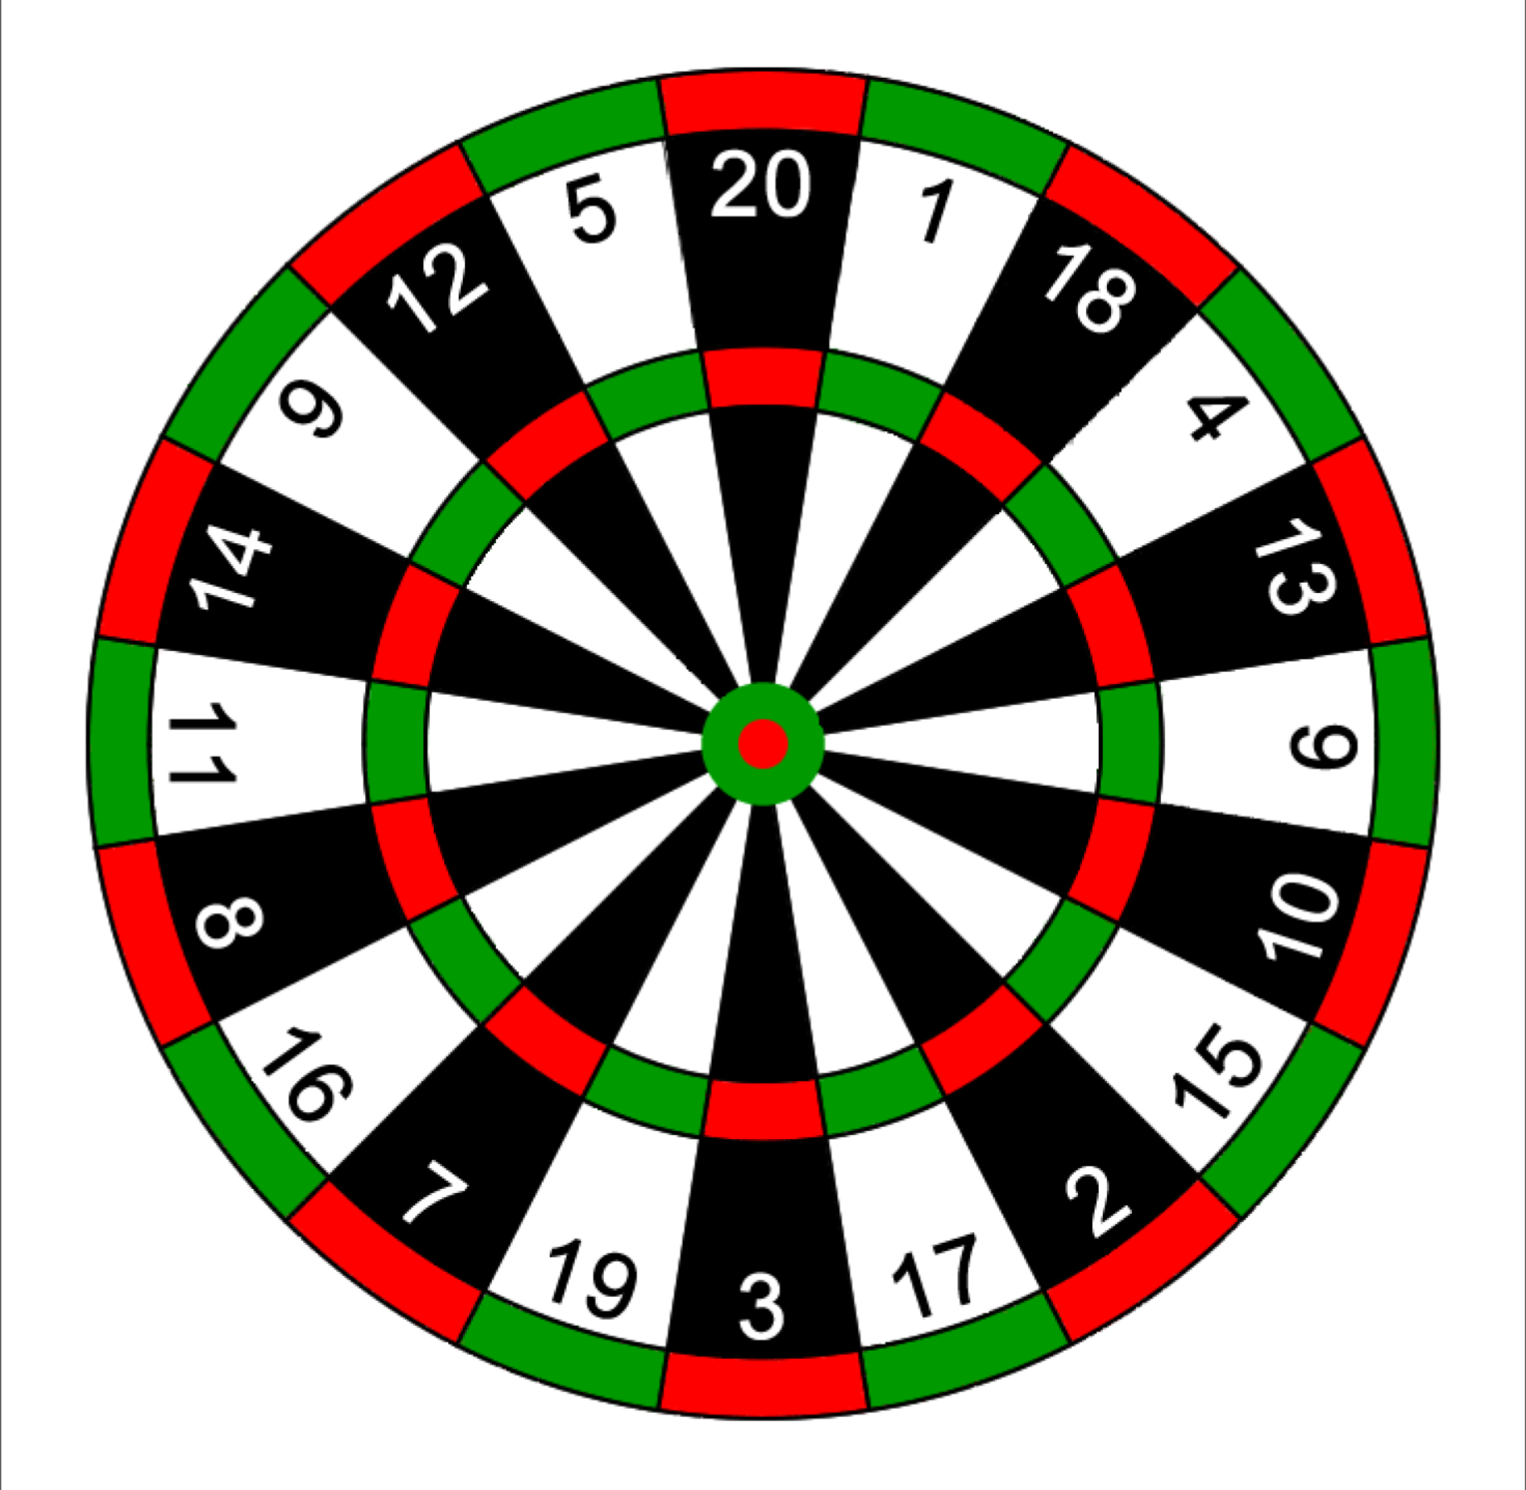

***22 Rifle Iron Ladder Target #3*** *Date of Challenge: __________________ Location: ________________*

*Shooter #1 Full Name: ________________________ Signature: ____________________________*

*Shooter #2 Full Neme: ________________________ Signature: ____________________________*

*Score: ___________ Distance: Yards: 10 Rounds: 10 (Score the most points)*