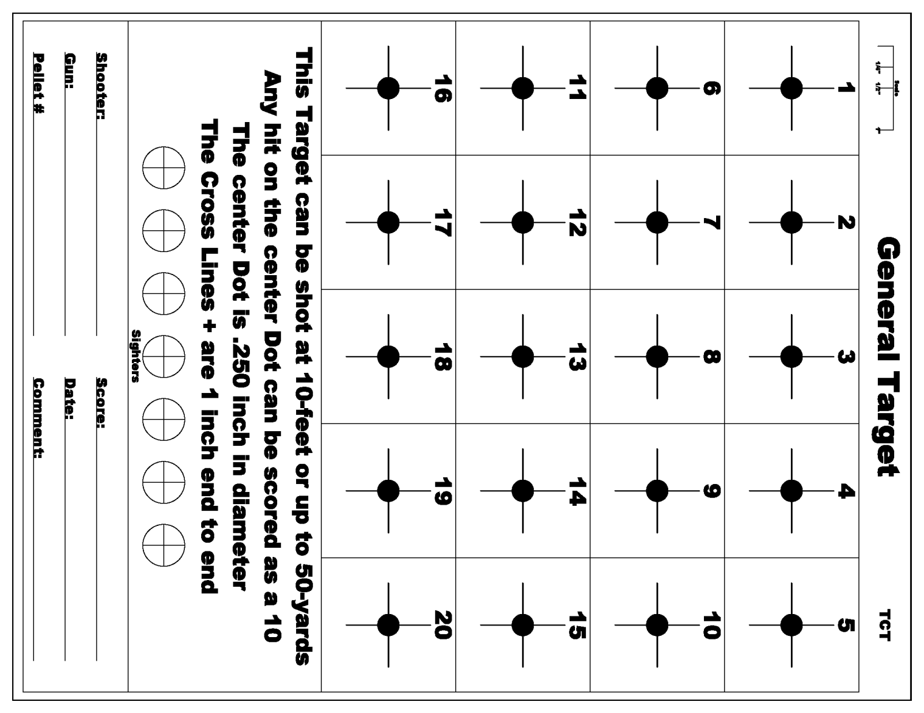

**Rifle .22 Iron Ladder Target Number Five**

Shooter: _____________________________________ Shooter Sign: ______________________________________

Date: __________________________ Score: _______________________

Other Ladder Person: __________________________________ Sign: _____________________________

**This target is be shot at the distance of 8 yards Iron/ 15 yards Optic. Total round count is 20. One shot per numbered square.** **All Shots must be within Center to be Counted**