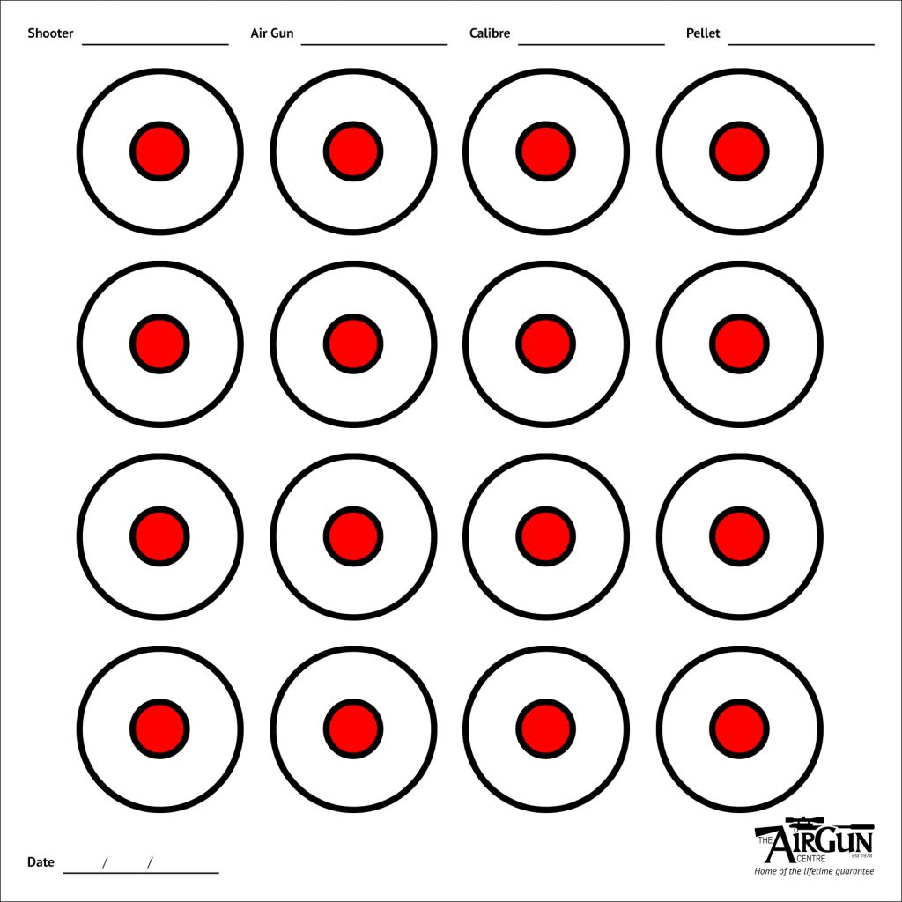
Rifle Ladder Target Number Four
Shooter: ________________________________ Sign: _______________________________
Date: _______________________ Round Count: 16 – one shot in each circle @ 25 yards
Score: ____________
Other Ladder Person: _______________________ Sign: ______________________________

