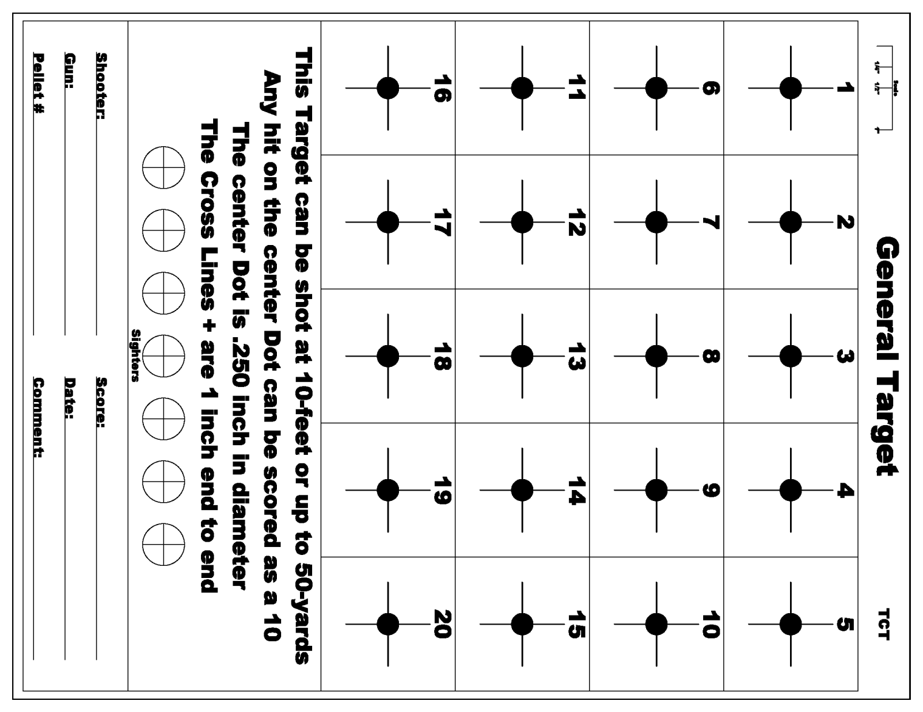

Shooter: _____________________________________ Shooter Sign: ______________________________________

Date: __________________________ Score: _______________________

Other Ladder Person: __________________________________ Sign: _____________________________

**This target is be shot at the distance of 20 yards. Total round count is 20. One shot per numbered square.**

**Rifle Ladder Target Number Two**