Page 1 of 3

From Walter Julius Kuleck

𝗧𝗵𝗲 "𝗖𝗼𝗺𝗺𝗮𝗻𝗱𝗲𝗿" 𝗩𝗲𝗿𝘀𝗶𝗼𝗻 𝗼𝗳 𝘁𝗵𝗲 𝗔𝘂𝘁𝗼𝗺𝗮𝘁𝗶𝗰 𝗖𝗼𝗹𝘁 𝗣𝗶𝘀𝘁𝗼𝗹, 𝗖𝗮𝗹𝗶𝗯𝗿𝗲 .𝟯𝟴

This is the Model L Colt Pocket Hammer .38, the 4 1/4" barrel version of the 6" barrel

Automatic Colt Pistol, Calibre .38. While the FN Model 1899/1900 was Browning's first

production automatic pistol, the Automatic Colt Pistol was his first in the USA--and the

first domestic production auto pistol in the USA.

The full-size Colt .38s, Military and Sporting Models, were much like M1911 long slide;

perhaps comfortable to shoot, but awkward to carry. Thus, Colt introduced the Pocket

Hammer. Production of the 31,000 or so Pocket Hammers ran from 1903 through 1927.

The distinctive design feature of the Military, Sporting, and Pocke Hammers was their two link parallel-ruler action. Rather than tilting down on one link at the breech as seen in the

.45 calibre Models 1909, 1910, and 1911, the barrels of the .38s swung down and back on

two links, one at the muzzle and one at the breech, while remaining parallel to the line of

sight. While the parallel-link calibre .45 Models 1905 and 1907 postdated the Hammer,

the Pocket Hammer ran for over twenty years after those .45s to be the last of the type.

It's apparent that the Pocket Hammerless models, even handier and easy to carry,

supplanted the Pocket Hammer. The blowback Hammerless pistols were simpler and less

costly to manufacture than the Hammers.

Several important points should be made here. First, while the "Calibre .38 Rimless

Smokeless" cartridge donated its 38mm case to the .38 Super, the higher pressure Super

cartridge should not be chambered in the parallel-ruler .38s. Inexplicably, it wasn't until

1940 or '41 that Colt finally, formally issued a statement to that effect.

Second, unlike later Browning designs, the Pocket Hammers have no safeties of any kind--

save the half-cock hammer notch. Presumably the shooter is expected to carry the pistol

with an empty chamber, or to seat the hammer on its half-cock notch whilst carrying. In

the former case the slide is racked to load the chamber and cock the hammer before

firing. In the latter, the hammer is cocked on the draw, in the manner of a Colt singleaction revolver.

Lastly, contemporary Colt literature did not refer to, or even mention, a year model, e.g.,

"Model 1903" for the Pocket Hammer. Such designations seem to be a shorthand for

collectors, to the point that Colt archive letters use (misuse?) year model in reference to

the Pocket Hammer, specifically "Model 1903." The practice has resulted in two different

Colt "Models 1903" and for me the attendant ambiguity. More on that at another time.

Page 2 of 3

The Colt .38s are an interesting starting point to the saga of Browning's design evolution.

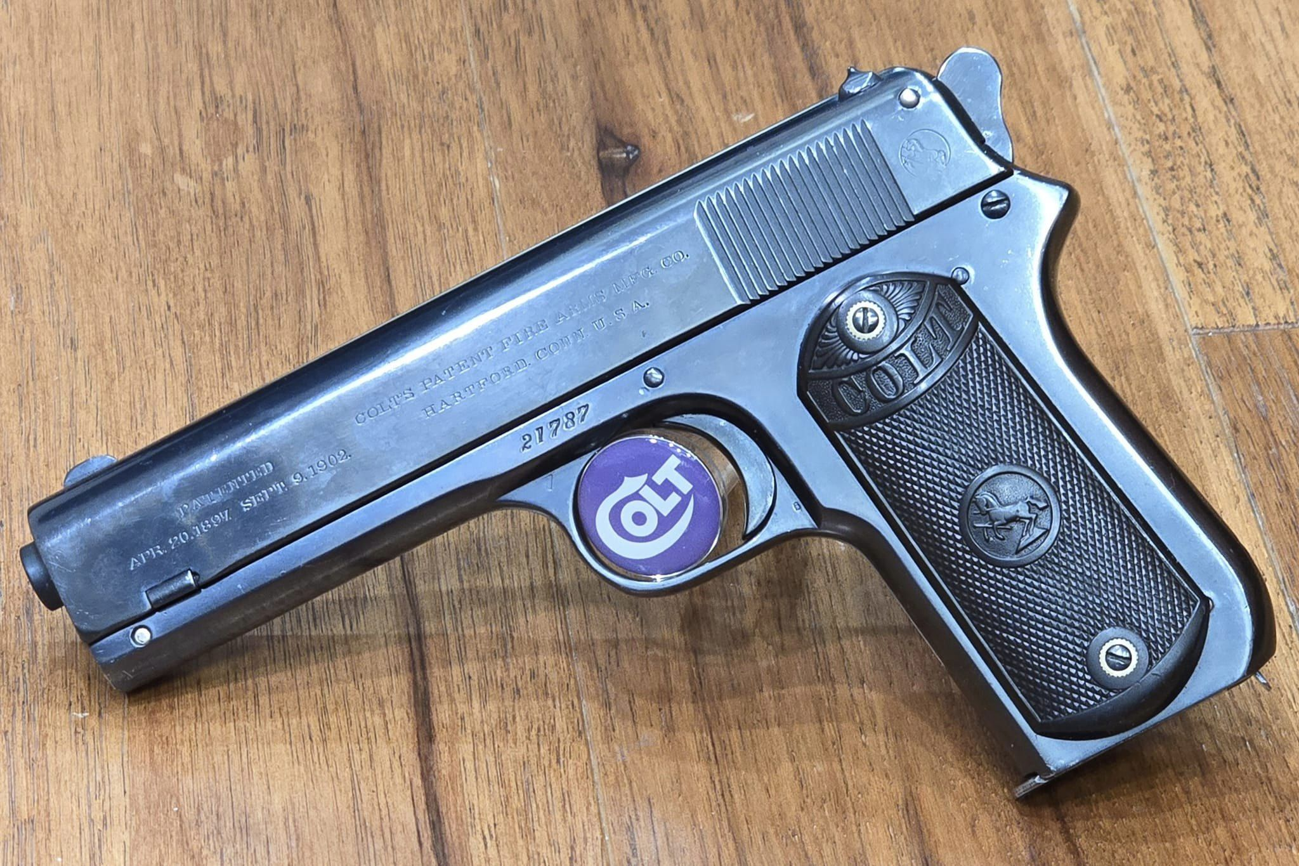

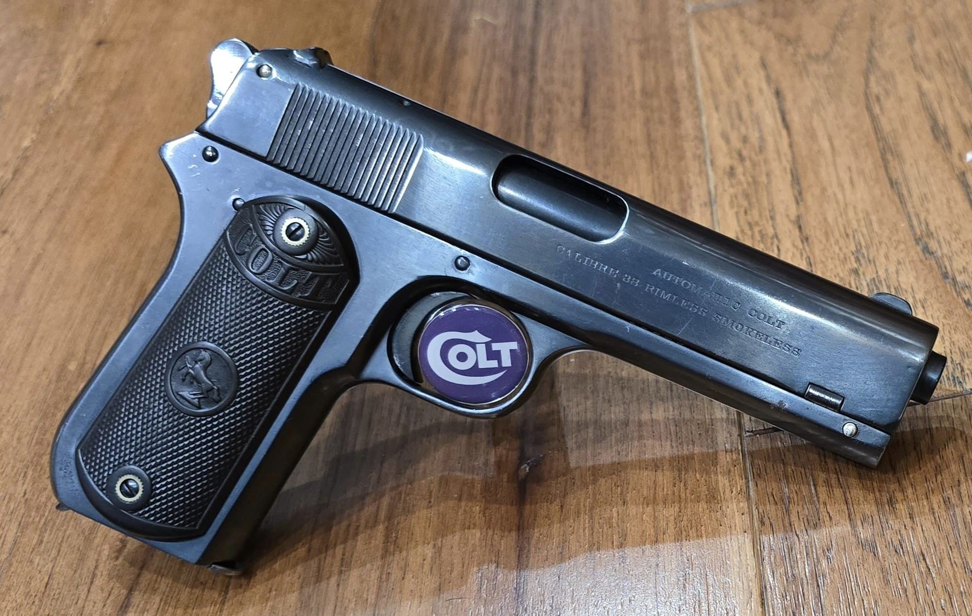

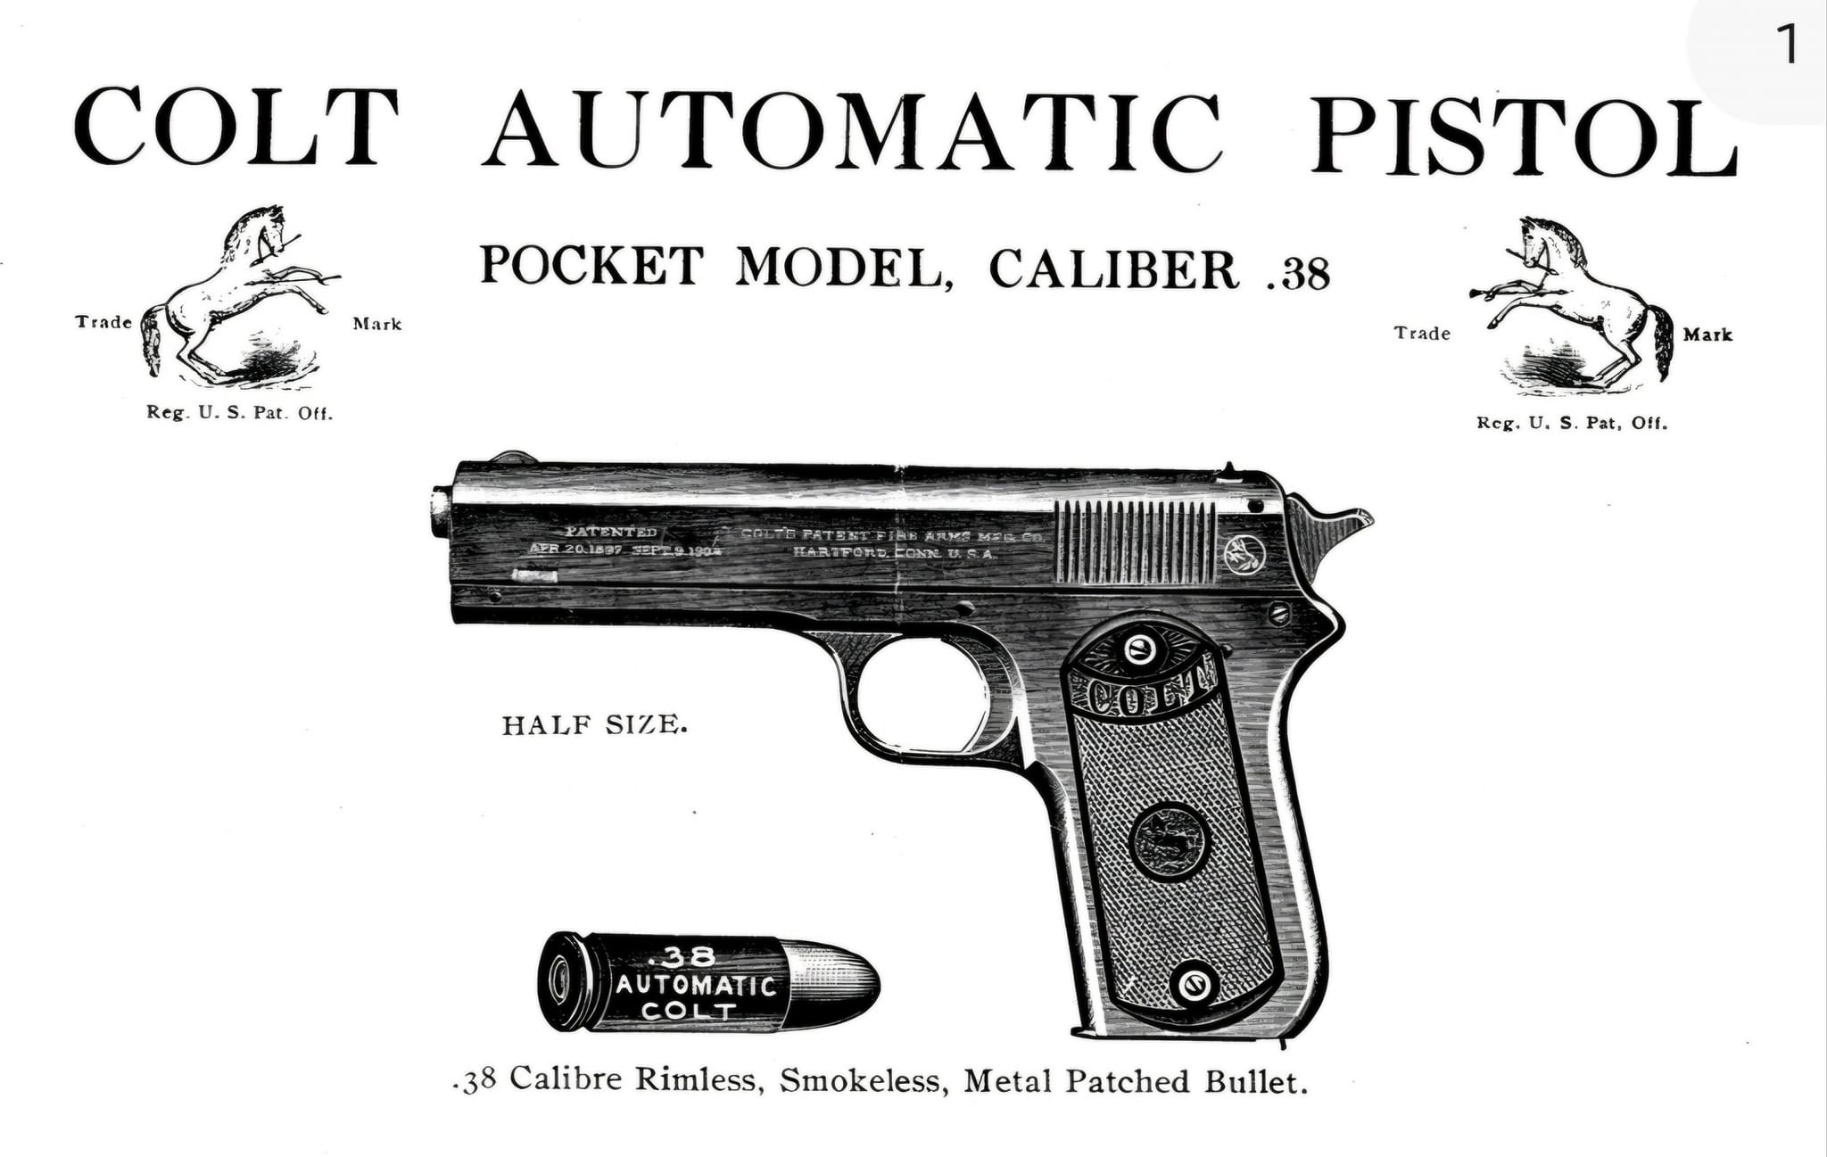

Page 3 of 3