No timer in a gunfight? Well, there’s time.
Measuring your time as well as your accuracy isn’t without value

From: The Tactical Wire : Thursday, February 20

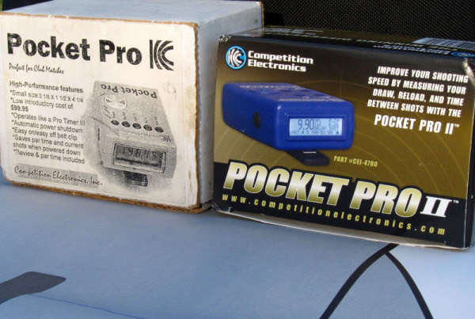
Now we come to the statement that “there’s no timer in a gunfight.” That’s true – and it was meant to address one part of the firing solution, by no means all of it.
So, from “Active Self Protection” in social media, we have a rundown of surveillance videos of actual shootings and the statement that “there’s no timer in a gunfight” is a “wrong adage.”
Is he right? It doesn’t matter, as he provides a critical bit of information that’s more than relevant. We find we can learn something, even when the original statement is a bit off point.
He shows still images from videos collected from various robberies. When the issue is “time to the first shot,” he has the goods on what par times should be – with qualifications. He notes that the visual cue to begin your draw will actually be “slightly faster” than the response to the audio cue of the timer.
That’s a fair assessment.
Further, his photos illustrate his points. I don’t have his permission to show the images (though they’re on his social media accounts), but a description suffices.
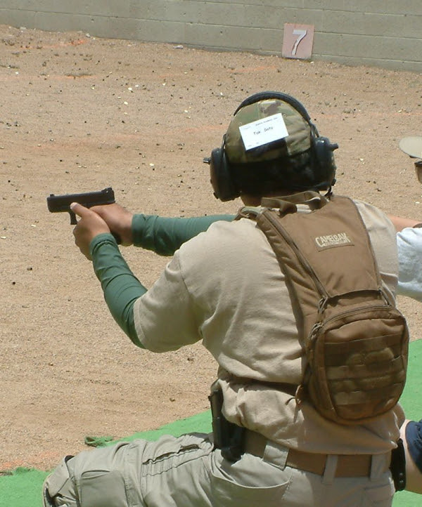
The student on line is looking to the side, away from his target. While his gun isn’t aimed in, the point is the same: you have about 1.5 seconds to exit the kill zone and/or make your hit.
If the attacker, with gun pointing at the victim, looks away to the point that the defender is (in the very short term) looking into the attacker’s ear, there is about 1.5 seconds for the defender to get that first hit, drawing from concealment.
Understand that the distance to the target is “across the counter” in a robbery. The commentator, John Correia, has three images to illustrate; #1, the offender looks away, #2, the offender turns back, sees and #3, “orients” to the event, but he’s behind the shot at 1.5 seconds from his diverted attention.
That’s a fair piece of information right there. If you can see his ear – and make an accurate hit from concealment in 1.5 seconds – it’s unlikely he can respond in time to stop your shot. That doesn’t mean he’s through – not at all. If he quits from a gunshot injury, you may be fine.
I’m not for hanging around to find out.
And, even if he shoots you in the heart – survivable or not – you could still have the time to put that round and another into the offender. (See “pyrrhic victory” for more information.)
Correia says that he sees that kind of timing in video-after-video; it’s more than a single example. I believe him. From “the drop” – the offender is aimed in, watching you, the time you have is just about a third of that, in his estimation, at .6 seconds. He’s seen people killed on video trying to beat that. Finally, he shows a photo array of the attacker moving eyes and nose away from you – giving you about one second to make that hit.
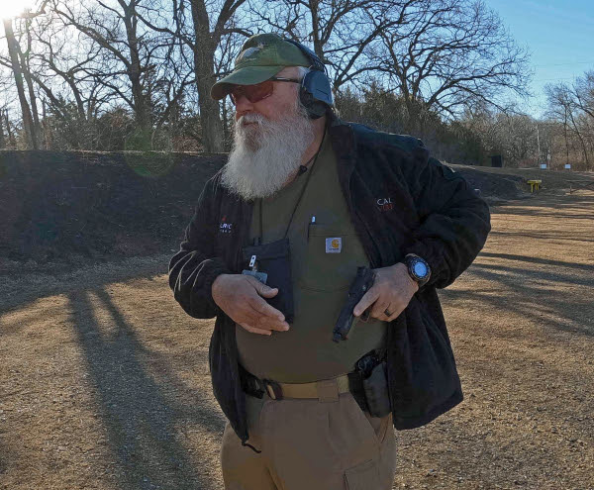
Can you make that draw – and hit – in that time limit, 100%, no fumbles and zero misses? Time to hit the dry practice and square range.
If you can absolutely make that draw-to-a-hit in one second, 100%, zero fumbles and zero misses, “he cannot beat you to it.”
That means you have a hit in him just before he gets a hit on you. Again, sticking around to see if that shot worked is a problem.
He goes on to drawing on an attacker who, for some reason, shows you the back of his head. That’s a two-second window, his “private citizen standard,” and the attacker can’t get a hit on you before you get one hit (likely more, for some I know) onto him.
He refers to “timer in a gunfight” as “fudd lore” (sic). Here’s my take, from a “boomer,” and, likely a “Fudd.” (Elmer appreciates the capitalization …)
What John is providing is not the worst information, by any means. In fact, it’s right helpful and we should appropriately appreciate his efforts on our behalf.
Now, take that draw, combine it with misdirection before the draw commences (e.g., a startled look over HIS shoulder) and add movement, you buy a few more tenths. Some movement, to the extent it’s possible, is critical. For a robbery vic behind a liquor store counter, there may be precious little space in which to move. Whatever movement you can make doesn’t hurt – if you’ve practiced it.
I was weary of our state’s qualification and the “side-step” dance routine at the closer distances – but, frankly, it makes sense. More explosive movement, a la Dave Spaulding – if there’s space available – is better. Often, the battle space isn’t as open and free of obstacles as the range.
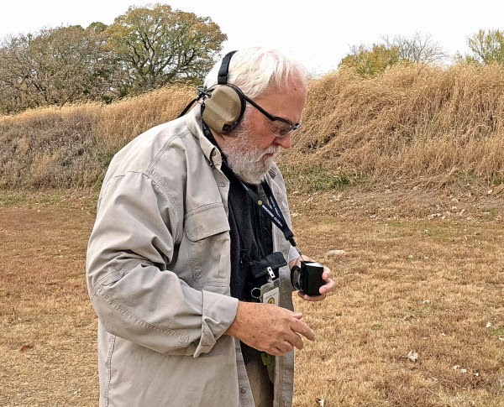
The timer, properly used, provides critical information to the shooter. Like a target, the timer has a critical function.
The reality of the "no timer in a gunfight" phrase is from the pursuit of split times, not draws to the first hit. Trying to get to sub-.15 splits is largely a waste of effort. Quick splits, if they’re achieved, prevent assessment during the event. This sometimes presents as an attacker who drops before a bullet gets there (no misses on the street, just unintentional hits) – or shooting after the offender gives up.
Neither of those are positive results.
After that first solid hit, the objective is to shoot in assessment time - and, yes, you need a timer to help you quantify that.

