**All Caliber #6**

**Rounds: 10 shots - Two magazines: one with 6 rounds, one with 4 rounds.**

**Time standard: (must use a shot timer)**

**Target: USPSA 1/3 size target (page 2)**

**Strings of fire: Pistol: from the low ready**

**Start with 6 round magazine with chamber loaded.**

**String 1: 2 shots @ 3 yards (iron) – 5 yards (optic) – time – 2 seconds**

**String 2: 2 shots @ 7 yards (iron) – 7 yards (optic) – time – 3 seconds**

**String 3: @ 7 yards (iron) – 10 yards (optic) – shoot 2 rounds, do emergency reload, shoot 2 more rounds – time – 6 seconds**

**String 4: 2 shots @ 15 yards (iron) – 20 yards (optic) – time – 5 seconds**

**Scoring:**

**Penalty: B -1 pt./C -2 pts./D -3 pts.**

**Over time .25 second equals negative 1 point**

**Deduct points from target for final score.**

**Total = 100 points**

**Attach the target to this paper.**

Shooters Full Name (please print): ________________________________

Date: __________________

Shooters Signature: _________________________________________

Person you challenged (please print): ____________________________

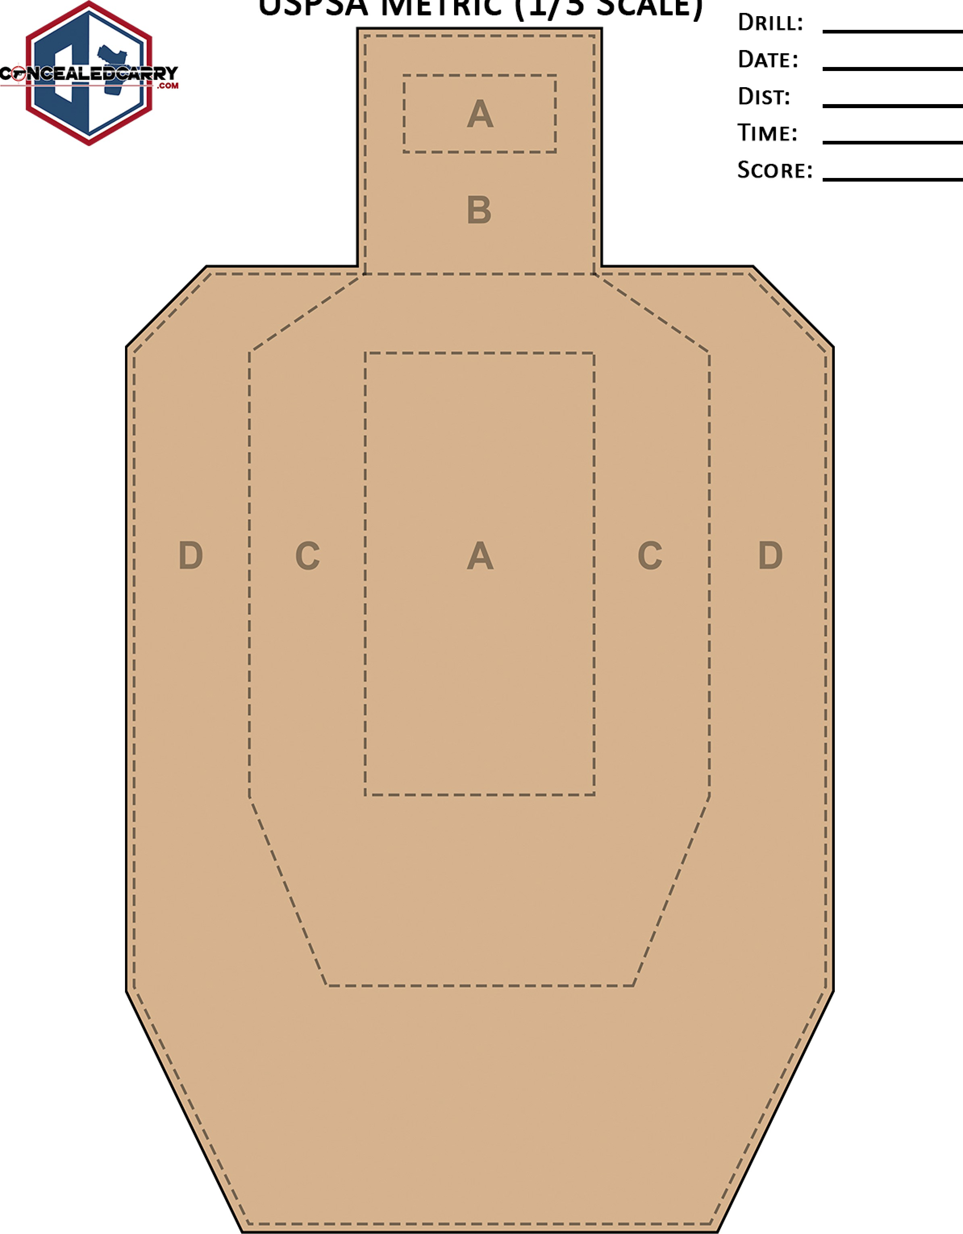

USPSA

METRIC

(1/3

SCALE)