: Modified Kilo Drill
All Caliber #5
Timer required. Set the timer for 3 seconds. For every second exceeding the par time, deduct three points from your overall score.
Rounds: 10 – Round in chamber – 1 or 2 mags as required.
Target: IDPA-type reduced target
Start position: low ready
Stings (5): Iron yardage as shown below. Optic yardage in parentheses.
• From the 10 (15)-yard line, on the signal, fire one round to the head box.
• From the 10 (15)-yard line. On the signal, fire two rounds to the body.
• From the 7 (10)-yard line. On the signal, fire three rounds to the body.
• From the 5 (7)-yard line. On the signal, fire two rounds to the body and one round to the head box (the classic failure drill).
• From the 5 (5)-yard line. On the signal, fire one round to the head box.
The goal is to score 80 percent or greater.
Score hits as follows: Hits in the A-zone are 10 points, B- and C-zone hits are seven points and D-zone hits are five points.

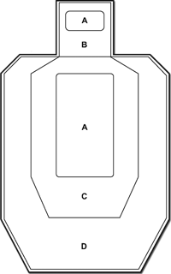
Shooter: ___________________
Signed: ____________________
Date: ______ Caliber:______
Witness: __________________
Signed: ___________________

Times:
String 1 _______ String 2 _____
String 3 _______ String 4_____
String 5 _______
SCORE:

All Caliber #5

